Functional Requirements Document
Template

TITLE: Explore The World
Team name: Team Explore The World
Team members: Mohamed Bashir, Karlee Fidek, Rishabh Prasad
GitHub URL: https://github.com/karleefidek/ENSE-374-Project.git

Version | Description of Change | Author | Date
1 | Section 1 | Team Explore The World | October 2, 2019
2 | Section 1, 2, 3.6, 4.1, 4.3, 4.4.1 | Team Explore The World | October 22, 2019

CONTENTS
1 INTRODUCTION 4
1.1 Purpose 4
1.2 Scope 4
1.3 Background 4
1.4 References 4
1.5 Assumptions and Constraints 4
2 METHODOLOGY 5
3 FUNCTIONAL REQUIREMENTS 5
3.1 Context 5
3.2 User Requirements 5
3.3 Data Flow Diagrams 6
3.4 Logical Data Model/Data Dictionary 6
3.5 Functional Requirements 6
4 OTHER REQUIREMENTS 6
4.1 Interface Requirements 6
4.2 Data Conversion Requirements 7
4.3 Hardware/Software Requirements 7
4.4 Operational Requirements 7
APPENDIX A - GLOSSARY 11

INTRODUCTION
The application we are hoping to create will take input from the users about their budget, the season of travel, and their interests and recommend a travel location for the user. The recommendation will include activities and information about the cultures present at the location.

Purpose
The purpose of the application is to allow users to choose a meaningful travel location based on their indicated preferences. It should be used to help users identify interesting and purposeful activities to participate in while travelling and where to travel to.

Scope
While the general application will work for users all around the world, the animations will use Regina, Saskatchewan as an initial starting position. Therefore, the application animations would not be realistic for users not in Regina. However, the functionality will work for users in various parts of the world. We hope to continually progress the application to accept more preferences and to recommend more locations to provide a more personalized recommendation to each user.

Background
We, as students, have a limited amount of time that we are able to spend travelling. Therefore, we feel the need to make the most of that time by choosing a prime location that will meet or exceed all of our expectations. We would like to create an application that helps us choose that prime location.

References

Assumptions and Constraints

Assumptions
We assumed that there is no application like this that will create copyright issues. We have assumed that the use of HTML, CSS, and PHP will allow us to produce our envisioned functionality for the project. We have assumed that we can use one of our computer science student domains as a host for our application.

Constraints
- We have limited experience coding with HTML, CSS, and PHP as two of us are currently taking CS 215 and learning the languages for the first time
- We are limited by time in multiple ways. We have a short amount of time to complete the full project. We also have limited time to meet due to busy schedules.
- We have never designed or created a model-view controller before
- The application will only provide a specific number of predefined options for each preference question (select hobbies, select budgets, etc.)
- The application will have a specific number of travel locations that will be used as we cannot include every location in the world

METHODOLOGY
We have done an overall assessment of requirements and tasks to be completed at the beginning of the project. We plan to revisit and re-evaluate these at the beginning of each milestone. For the application, we plan to get a basic and simple version of the project functioning and progressively improve and increase its functionality.

FUNCTIONAL REQUIREMENTS

Context
[Provide a context diagram of the system, with explanations as applicable. The context of a system refers to the connections and relationships between the system and its environment.]
Exhibit 2 - Generic Context Diagram
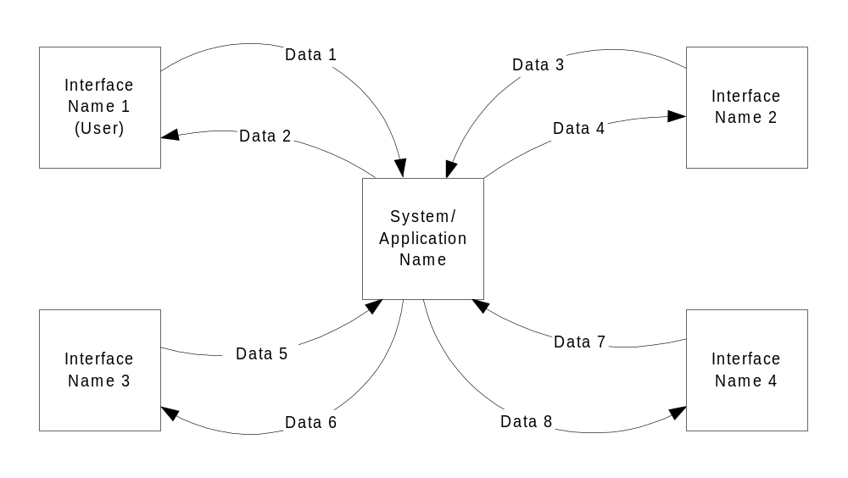

3.3 User Requirements
[Provide requirements of the system, user or business, taking into account all major classes/categories of users. Provide the type of security or other distinguishing characteristics of each set of users. List the functional requirements that compose each user requirement. As the functional requirements are decomposed, the highest level functional requirements are traced to the user requirements. Inclusion of lower level functional requirements is not mandatory in the traceability to user requirements if the parent requirements are already traced to them.
User requirement information can be in text or process flow format for each major user class that shows what inputs will initiate the system functions, system interactions, and what outputs are expected to be generated by the system. The scenarios should be comprehensive, to the extent that all user types and all major functions are covered. Give each user requirement a unique number. Typically, user requirements have a numbering system that is separate from the functional requirements. Requirements may be labeled with a leading “U” or other label indicating user requirements.]

Data Flow Diagrams
[Decompose the context level diagrams to determine the functional requirements. Data flow diagrams should be decomposed down to the functional primitive level. These diagrams are further decomposed during design.]

Logical Data Model/Data Dictionary
[Create the initial Logical Data Model. Describe data requirements by providing data entities, decomposition, and definitions in a data dictionary. The data requirements describe the business data needed by the application system. Data requirements do not describe the physical database and are not at the level of identifying field names.]

Functional Requirements
The functional requirements of this application are the ability to accept user input and the ability determine the best fitting travel location for the user. User input should be used and compared to location data to determine the location that best matches the user’s entered preferences.

OTHER REQUIREMENTS

Interface Requirements
- Initial start page – Basic, simple page that allows the user to choose to start the process of entering their preferences in order to reveal a travel recommendation.
- Question and preference input pages - Pages with simple input features that allow users to enter their travel preferences.
- Loading screen / animation page – Page that shows a plane animation from Regina to the recommended location
- Location recommendation page – Simple page that shows recommended location and suggested activities for user to participate in while travelling.

Data Conversion Requirements
[Describe the requirements needed for conversion of legacy data into the system.]

Hardware/Software Requirements
The software requirements for this application on the design side will be access to HTML, CSS and PHP. The only software requirement for user will be access to a web browser.

Operational Requirements
[Provide the operational requirements in this section.
Do not state how these requirements will be satisfied. For example, in the Reliability section, answer the question, “How reliable must the system be”? Do not state what steps will be taken to provide reliability.
Distinguish preferences from requirements. Requirements are based on business needs, preferences are not. If, for example, the user requires a special response but does not have a business-related reason for it, that requirement is a preference.
Other applicable requirements on system attributes may be added to the list of subsections below.]
Operational requirements describe how the system will run and communicate with operations personnel.

Security and Privacy
- Loss or corruption of data – A loss of data would mean that our application would not function properly as our application relies on the comparison of input to stored data.
- Disclosure of privileged/privacy information about individuals - The application will not store any sensitive information about the users and therefore, this is not a concern for our application. Once the user is done with their session, all information relating to them will be destroyed
- State the type(s) of security required. Include the need for the following as appropriate:
- Physical security.
- Access by user role or types.
- State access control requirements by data attribute. For example, one group of users has permission to view an attribute but not update it while another group of users has permissions to update or view it.
- State access requirements based on system function. For example, if there is a need to grant access to certain system functions to one group of users, but not to another. For example, "The system shall make Function X available to the System Administrator only".
- State if there is a need for certification and accreditation of the security measures adopted for this application]
The Security Section describes the need to control access to the data. This includes controlling who may view and alter application data.

Audit Trail
[List the activities recorded in the application’s audit trail. For each activity, list the data recorded.]

Reliability
A. [State the following in this section:
- State the damage can result from failure of this system—indicate the criticality of the software, such as:
- Loss of human life
- Complete or partial loss of the ability to perform a mission-critical function
- Loss of revenue
- Loss of employee productivity
- What is the minimum acceptable level of reliability?
B. State required reliability:
- Mean-Time-Between-Failure is the number of time units the system is operable before the first failure occurs.
- Mean-Time-To-Failure is the number of time units before the system is operable divided by the number of failures during the time period.
- Mean-Time-To-Repair is the number of time units required to perform system repair divided by the number of repairs during the time period.]
Reliability is the probability that the system processes work correctly and completely without being aborted.

Recoverability
[Answer the following questions in this section:
A. In the event the application is unavailable to users (down) because of a system failure, how soon after the failure is detected must function be restored?
B. In the event the database is corrupted, to what level of currency must it be restored? For example “The database must be capable of being restored to its condition of no more than 1 hour before the corruption occurred”.
C. If the processing site (hardware, data, and onsite backup) is destroyed, how soon must the application be able to be restored?]
Recoverability is the ability to restore function and data in the event of a failure.

System Availability
[State the period during which the application must be available to users. For example, “The application must be available to users Monday through Friday between the hours of 6:30 a.m. and 5:30 p.m. EST. If the application must be available to users in more than one time zone, state the earliest start time and the latest stop time. Consider daylight savings time, too.
Include use peak times. These are times when system unavailability is least acceptable.]
System availability is the time when the application must be available for use. Required system availability is used in determining when maintenance may be performed.

General Performance
[Describe the requirements for the following:
A. Response time for queries and updates
B. Throughput
C. Expected rate of user activity (for example, number of transactions per hour, day, or month, or cyclical periods)
Specific performance requirements, related to a specific functional requirement, should be listed with that functional requirement.

Capacity
[List the required capacities and expected volumes of data in business terms. Do not state capacities in terms of system memory requirements or disk space—if growth trends or projections are available, provide them]

Data Retention
[Describe the length of time various forms of data must be retained and the requirements for its destruction.
For example, “The system shall retain application information for 3 years”. Different forms of data include: system documentation, audit records, database records, access records.]

Error Handling
[Describe system error handling.]

Validation Rules
[Describe System Validation Rules.]

Conventions/Standards
[Describe system conventions and standards followed.
For example: Microsoft standards are followed for windows, Institute of Electrical and Electronics Engineers (IEEE) for data formats, etc.]

APPENDIX A - GLOSSARY
[Define terms, acronyms, and abbreviations used in the FRD.]

